

**1. Install a Linux distribution (e.g., CentOS or REDHAT) on a virtual**

**machine or in Cloud.**

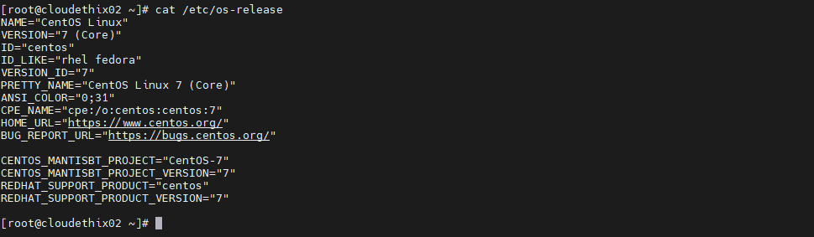

**2. Demonstrate basic Linux commands (e.g., ls, cd, pwd, mkdir, rm, rmdir, cp, mv, cat, less, more, head, tail,**

**sort, uniq, wc, diff, sdiff, cmp, echo, date, uptime, hostname, w , hostnamectl, clear, exit, script).**

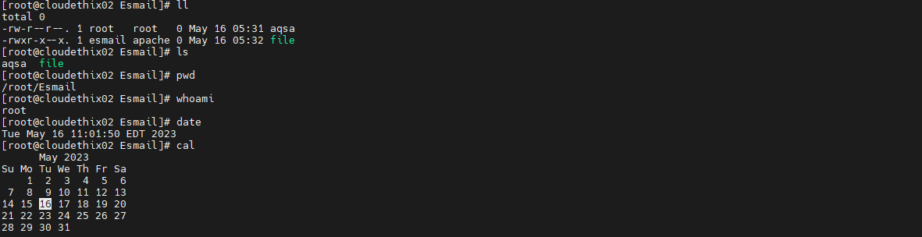

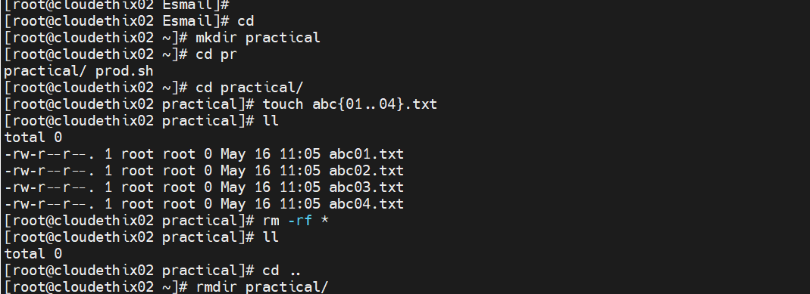

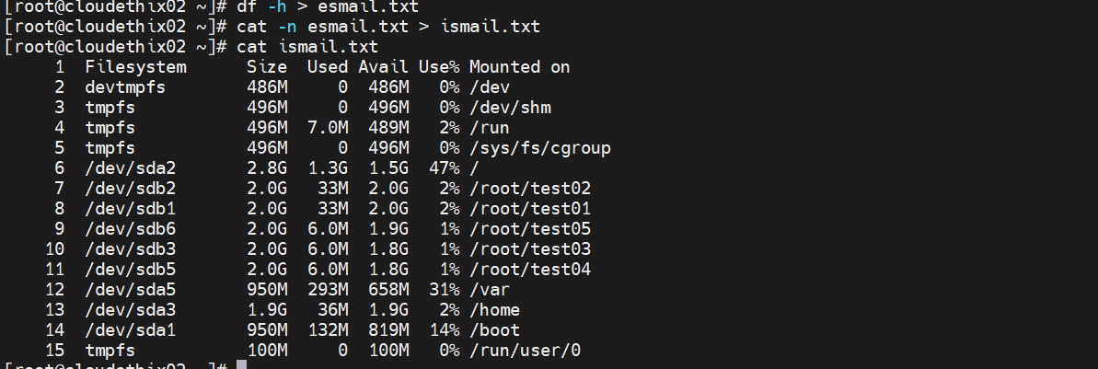

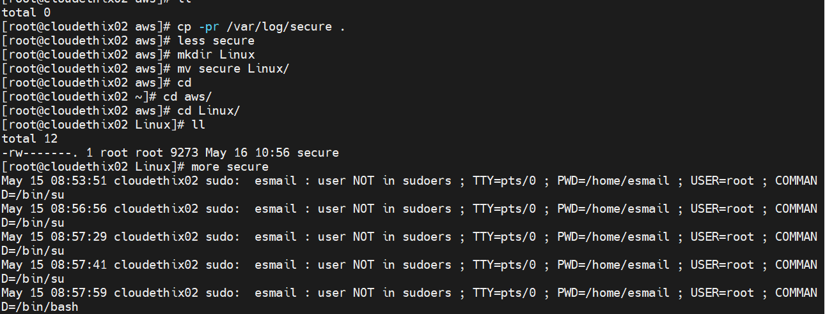

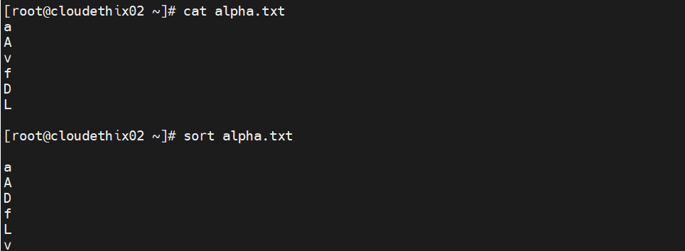

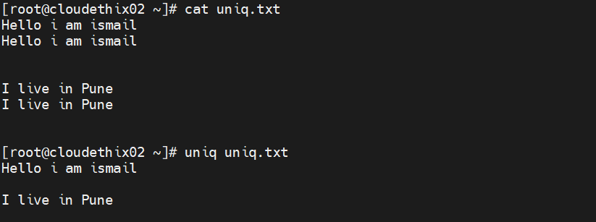

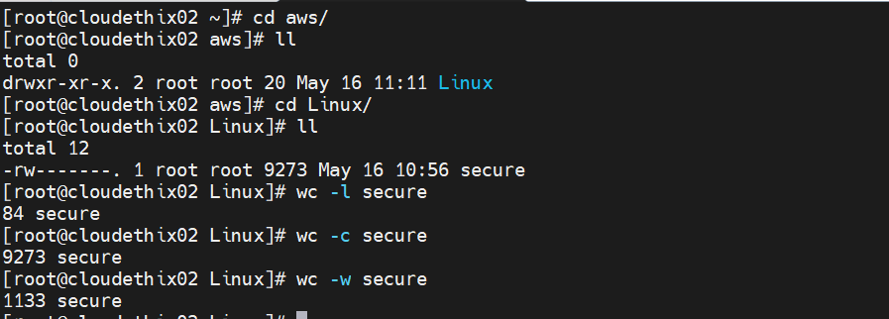

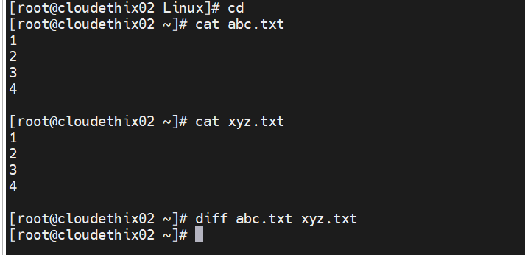

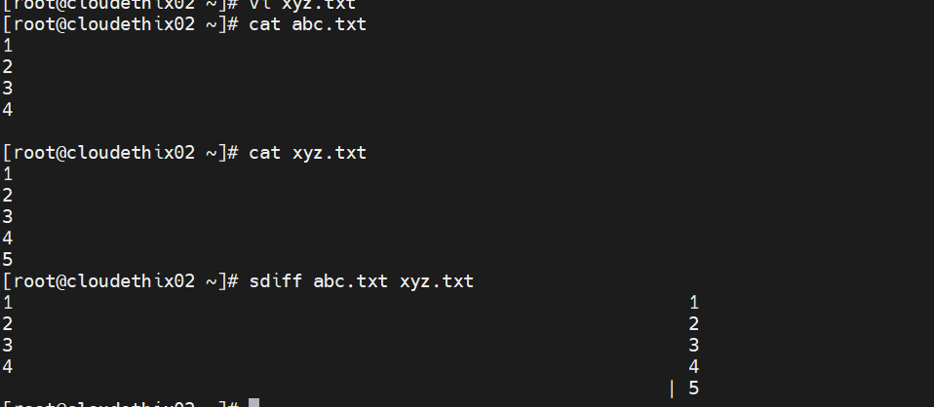

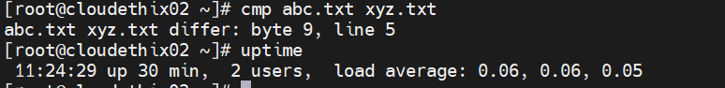

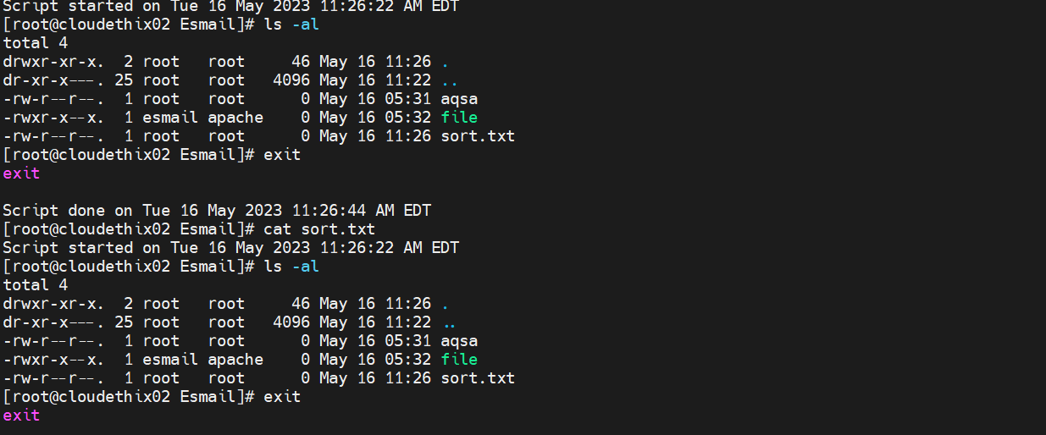

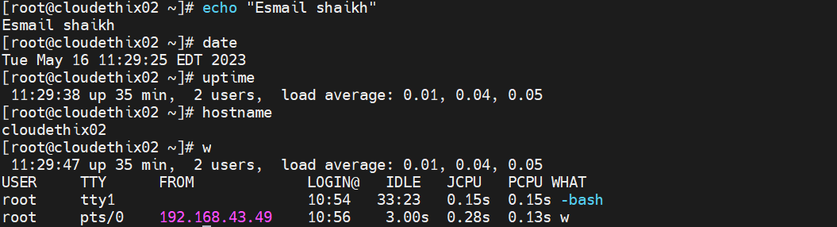

**3. Explore the Linux file system hierarchy in Linux (e.g., /, /home, /etc,**

**/usr, and /var).**

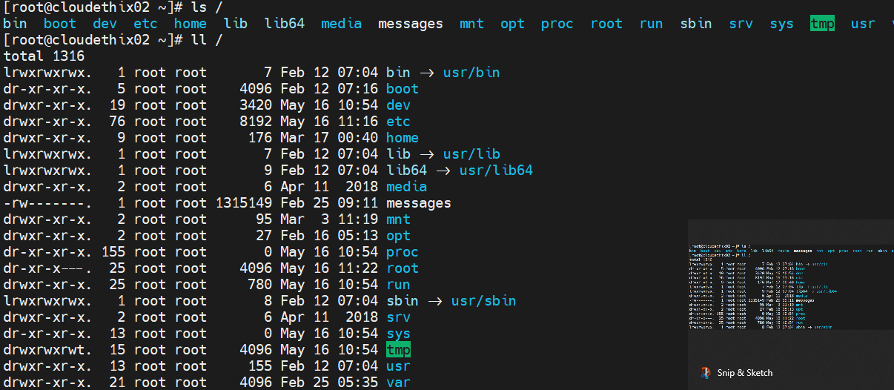

**4. Demonstrate to use a text editor with 8 commands (e.g., vi, vim or**

**nano).**



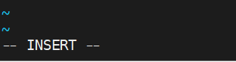

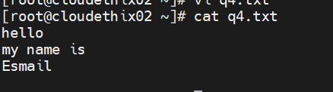

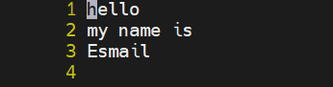**:set nu**

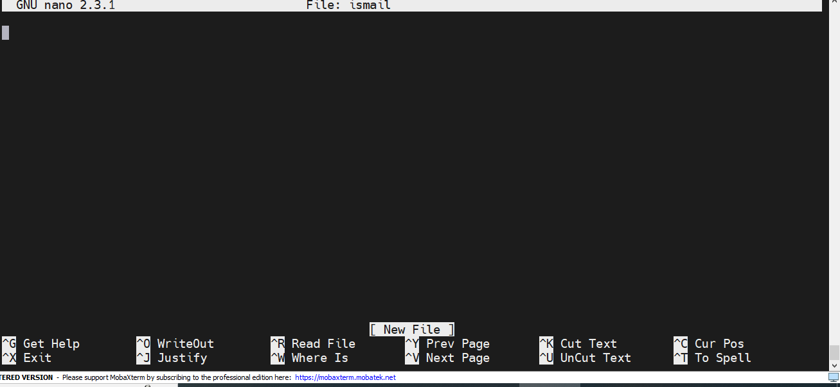

**5. Demonstrate file permissions and ownership to single or all files in all directories (e.g.,**

**chmod, chown, and chgrp)**

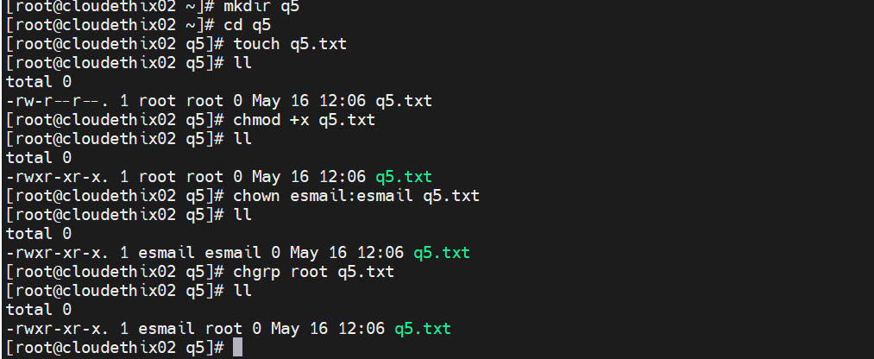

**6. Demonstrate about process management (e.g., ps, top, kill and nice)**

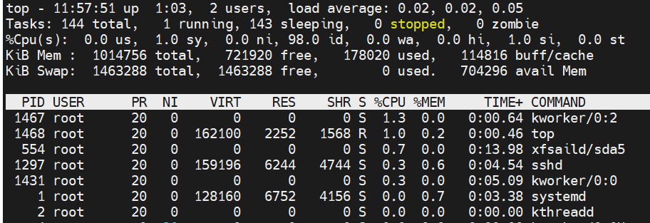

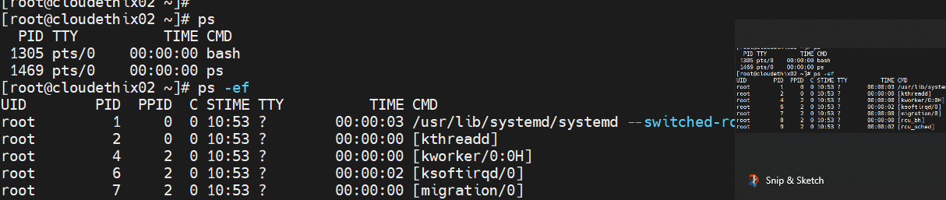



**7. Demonstrate to use input/output redirection and piping (e.g., >, >>, <, |, and tee).**

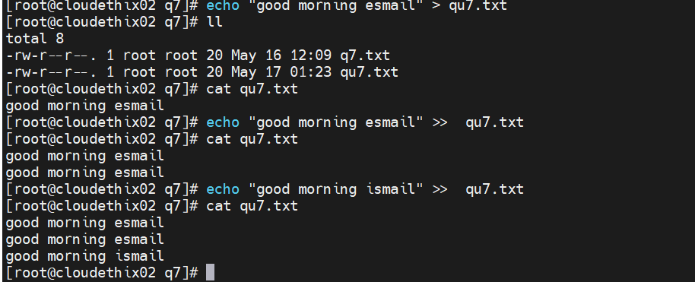

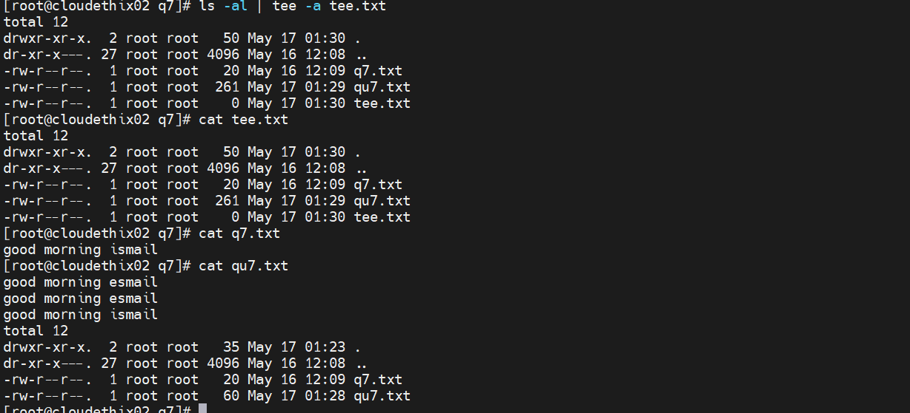

**8. Familiarize yourself with package management. Download and install rpm packages**

**using rpm command. (e.g., yum, or rpm).**

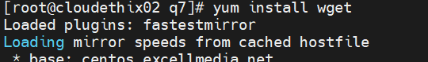

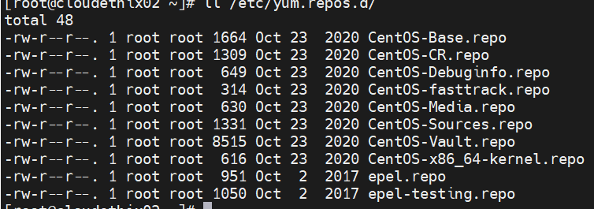

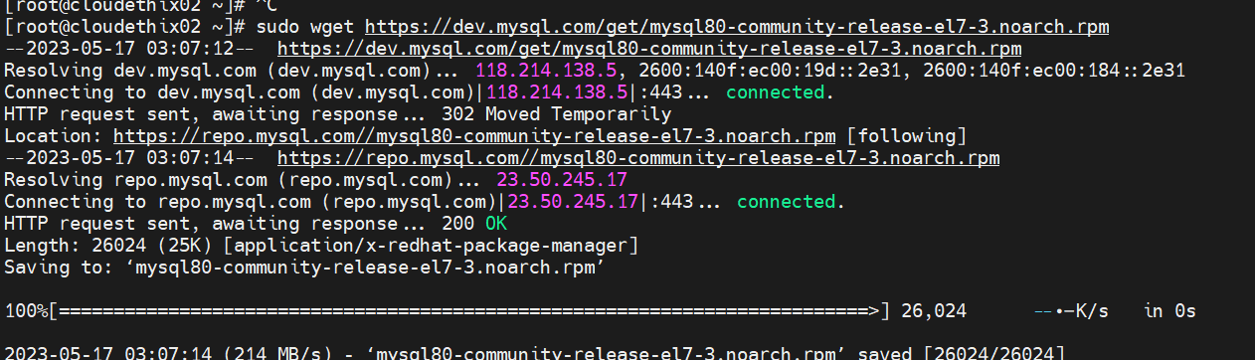

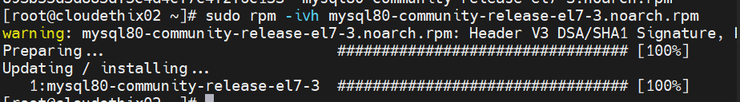

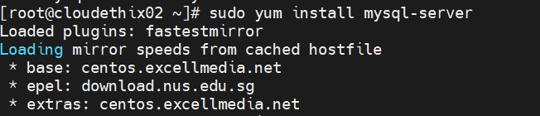

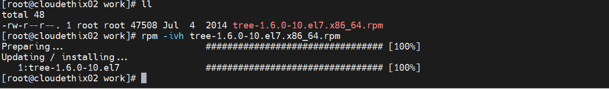

**09. Configure and manage services httpd & nginx (e.g., systemctl and service). Use default**

**index.html as home page , change default document root of http.**

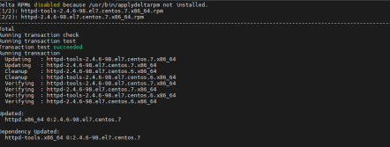

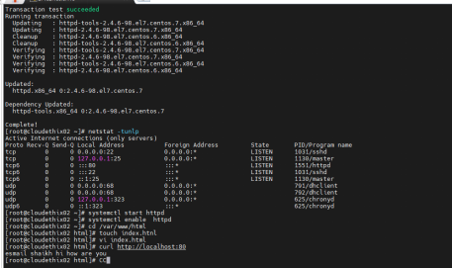

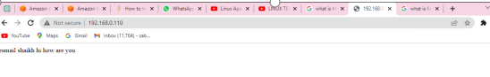

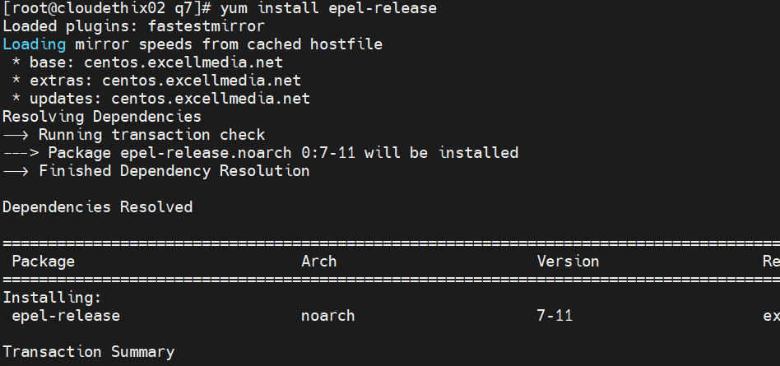

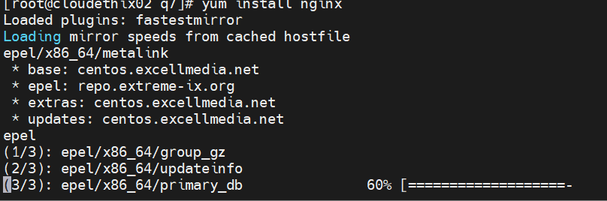

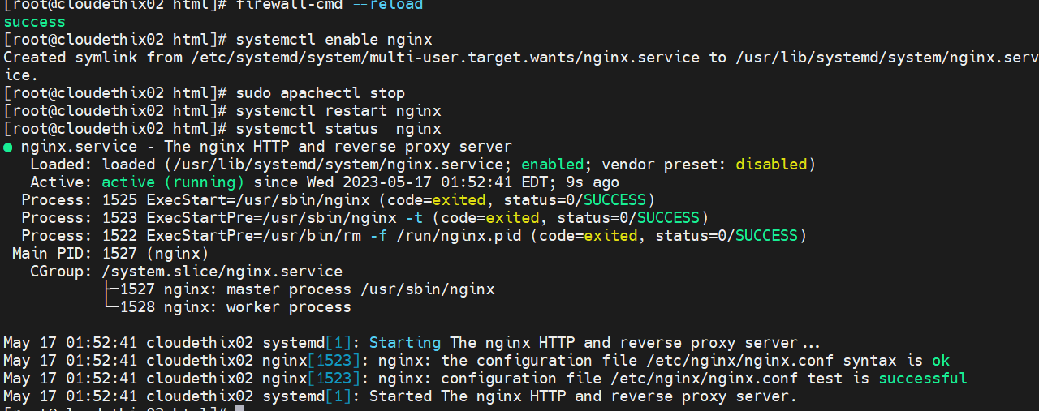

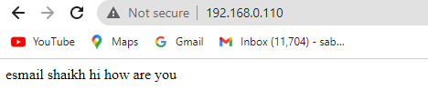

**10. Demonstrate about users and groups (e.g., adduser, usermod, groupadd, and**

**groupmod).**

**Create multiple users & groups. Add users to multiple groups & modify the user-level &**

**group-level permissions**

